

**BN002/BN013/BN104/BN120/BN997**

**Assessment 2: Database Design**

**Submitted by: Derek McCarthy, B00007439**

**Submission date**

**Declaration**

I hereby certify that this material, which I now submit for assessment on the programme of study leading to the award of Ordinary Degree in Computing in the Institute of Technology Blanchardstown, is entirely my own work except where otherwise stated.

Author: Derek McCarthy Dated: 18/12/2016

**Table of Contents**

# Section 1 Normalisation

Task 1 - Normalisation and 3rd NF Explained Page 4

Task 2 - Relational Model and 3rd NF Page 5

Task 3 - DDL and DML Page 6, 7

# Section 2 Database Design

Task 1

ERD First Draft Page 8

ERD Second Draft Page 9

ERD Third Draft Page 10

Task 2 - Relational Model Page 11

Task 3 - Normalisation 3NF Page 12, 13

Sample Data Tables Pages 14-16

# Section 1 Normalisation

**Task 1**

Normalisation is the process of reducing and removing data duplication in a database. It is a series of steps undertaken to deal with ways in which database tables can become too convoluted. By applying normalisation, you reduce the chances of anomalies occurring in the database such as,

* ***Insert anomaly*** - when you have to insert the same data into multiple areas
* ***Update anomaly*** - when you have to update the same information in multiple areas
* ***Delete anomaly*** - when performing a deletion unintended data is lost

A database’s tables, can be considered well-structured after 3rd normal form. The steps required to transform a database into 3rd normal form is,

1. ***1st Normal Form*** involves removing repeating groups. A repeating group is, “a group of attributes which have more than one value for each instance of the primary key”. To do this you remove the repeating groups to a new table along with a copy of the original tables primary key to form a composite primary key. A table is considered to be in 1st normal form when there are no repeating groups, all data values are atomic, each field has a unique name and the table has a primary key.
2. ***2nd Normal Form*** involves removing partial dependencies on the table with a composite primary key. An attribute is considered partially dependant if it only relies on part of the composite primary key. If a non-key attribute is only dependant on part of the composite primary key, you move this attribute to a new table with a copy of the primary key it’s dependant on which then becomes that new tables primary key. If all non-key attributes are dependent on ALL PARTS of the composite primary key, the tables can then be considered in second normal form.
3. ***3rd Normal Form*** involves removing transitive dependencies. A transitive dependency is an attribute that is dependent on another non-primary key attribute. If an attribute is dependent on a non-primary key attribute, then you move this attribute to a new table and give it a primary key. Then you make this primary key a foreign key in the original table where the attribute was removed.

**Task 2**

***Relational Model***

***Transaction*** (ReceiptID (PK), ReceiptDate, StaffID, StaffName, ProductName, QuantityOrdered, ProductPrice)

***1st Normal Form – Repeating Groups***

In this step, I will be removing the repeating groups and moving them to a new table ***Products***. The repeating groups are **ProductName**, **QuantityOrdered** and **ProductPrice**. I will then give the new table a primary key (**ProductID**) and a copy of the original primary key (**ReceiptID**) which will also be a foreign key. Together these two keys will form a composite primary key.

***Transactions*** (ReceiptID (PK), ReceiptDate, StaffID, StaffName)

***Products*** (ReceiptID (**PK**, **FK**), ProductID(**PK**), ProductName, QuantityOrdered, ProductPrice)

***2nd Normal Form – Partial Dependencies***

In this step, I will be looking for partial dependencies in the ***Products*** table with the composite primary key of (**ReceiptID(PK)** & **ProductID(PK)**)**.** As **ProductName** and **ProductPrice** are only dependant on **ProductID** and not the composite primary key of (**ReceiptID(PK)** & **ProductID(PK)**)**.** I will move **ProductName** and **ProductPrice** to a new table **Product_Details** along with a copy of the primary key they are dependent on **ProductID. ProductID** will then become a foreign key in the **Products** table.

***Products*** (ReceiptID (PK, FK), ProductID(PK, **FK**), QuantityOrdered)

***Product_Details*** (ProductID(PK), ProductName, ProductPrice)

***3rd Normal Form – Transitive Dependencies***

In this step, I will be looking for transitive dependencies. As ***StaffName*** in the ***Transactions*** table is dependent on another attribute that is not the primary key I will move this to a new table ***Staff***. ***StaffID*** will become a foreign key in the ***Transaction*** table and the primary key in the ***Staff*** table.

***Transactions*** (ReceiptID (PK), ReceiptDate, StaffID (FK))

***Staff*** (StaffID(**PK**), Staff_First_Name, Staff_Surname)

***Final Tables***

***Transactions*** (ReceiptID (PK), ReceiptDate, StaffID (FK))

***Products*** (ReceiptID (PK, FK), ProductID(PK, FK), QuantityOrdered)

***Product_Details***(ProductID(PK), ProductName, ProductPrice)

***Staff*** (StaffID(PK), Staff_First_Name, Staff_Surname

**Task 3**

***Data Definition Language (DDL)***

CREATE TABLE Staff (

StaffID varchar (255) NOT NULL,

Staff_First_Name varchar (255) NOT NULL,

Staff_Surname varchar (255) NOT NULL,

PRIMARY KEY (StaffID));

CREATE TABLE Products_Detail (

ProductID varchar(255) NOT NULL,

ProductName varchar(255) NOT NULL,

ProductPrice double NOT NULL,

PRIMARY KEY (ProductID));

CREATE TABLE Transactions (

ReceiptID varchar(255) NOT NULL,

ReceiptDate date,

StaffID varchar (255) NOT NULL,

PRIMARY KEY (ReceiptID),

CONSTRAINT Transactions_StaffID_FK FOREIGN KEY (StaffID) REFERENCES Staff(StaffID));

CREATE TABLE Products (

ReceiptID varchar(255) NOT NULL,

ProductID varchar(255) NOT NULL,

QuantityOrdered INT (8) NOT NULL,

PRIMARY KEY (ReceiptID, ProductID),

CONSTRAINT Products_ReceiptID_FK FOREIGN KEY (ReceiptID) REFERENCES Transactions(ReceiptID),

CONSTRAINT Products_ProductID_FK FOREIGN KEY (ProductID) REFERENCES Product_Details(ProductID));

***Data Manipulation Language (DML)***

INSERT INTO Staff (StaffID, Staff_First_Name, Staff_Surname) VALUES

('S123', 'Mary', 'Jones'),

('S345', 'John', 'Doe');

INSERT INTO Product_Details (ProductID, ProductName, ProductPrice) VALUES

('P001', 'Cornflakes', 0.99),

('P002', 'LowFatMilk', 1.89),

('P003', 'Brennans Bread', 1.50);

INSERT INTO Transactions (ReceiptID, ReceiptDate, StaffID) VALUES

('R001', 01/11/2016, 'S123'),

('R002', 02/11/2016, 'S345');

INSERT INTO Products (ReceiptID, ProductID, QuantityOrdered) VALUES

('R001', 'P001', 1),

('R001', 'P002', 2),

('R002', ‘P003’, 1);

Use’s Composite PK

# Section 2 Database Design

## Task 1

***First Draft***

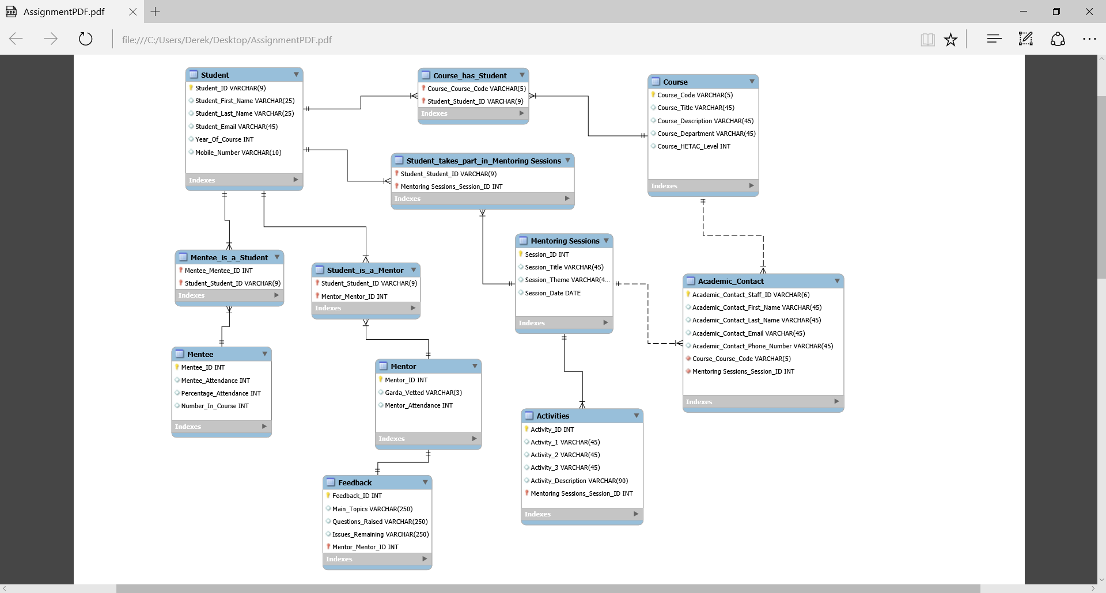

In this design, I was going to use the student table as a super class in which the mentee and the mentor table would have inherited the shared attributes. In the end, I decided to remove the student table as I was unsure on how queries would work while using inheritance.

**Second Draft**

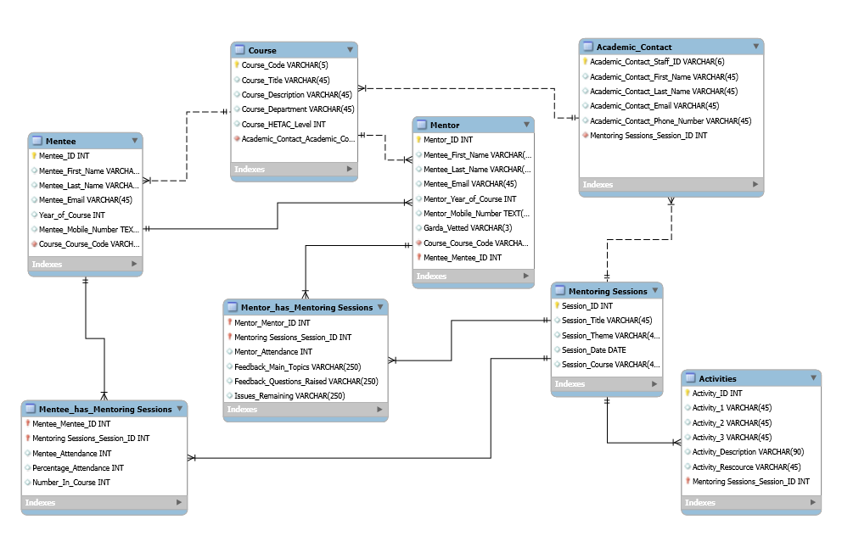

This draft is closer to my final draft. But I was not satisfied with the Mentoring Session table as I would have had repeating attributes (Date & Course).

**Final Draft**

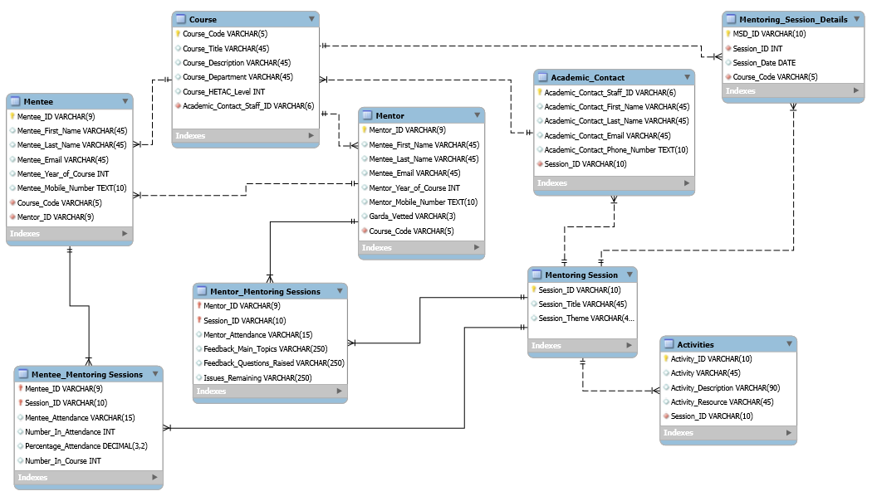

In this the final draft, I created a new table called **Mentoring_Session_Details**. I then gave the new table a primary key **MSD_ID** and moved **Session_Date** and **Session_Course** to the new table along with a copy of the primary key from the original table **Session_ID**. I did this at the ERD phase so I didn’t have to do it in the normalisation stage.

## Task 2

**Relational Model**

**Mentee** (Mentee_ID (PK), Mentee_First_Name, Mentee_Last_Name, Mentee_Email, Mentee_Year_Of_Course, Mentee_Mobile_Number, Course_Code (FK), Mentor_ID(FK))

**Mentor** (Mentor_ID (PK), Mentor_First_Name, Mentor_Last_Name, Mentor_Email, Mentor_Year_Of_Course, Mentor_Mobile_Number, Garda_Vetted, Course_Code (FK))

**Mentee_Mentoring_Sessions** (Mentee_ID (PK, FK ), Session_ID (PK, FK ), Mentee_Attendance, Number_In_Attendance, Percentage_Attendance, Number_In_Course)

**Mentor_Mentoring_Sessions** (Mentor_ID (PK, FK ), Session_ID (PK, FK ), Mentor_Attendance, Feedback_Main_Topics, Feedback_Questions_Raised, Issues_Remaining)

**Course** (Course_Code(PK), Course_Title, Course_Description, Course_Department, Course_HETAC_Level, Academic_Contact_Staff_ID(FK))

**Academic_Contact** (Academic_Contact_Staff_ID(PK), Academic_Contact_First_Name, Academic_Contact_Last_Name, Academic_Contact_Email, Academic_Contact_Phone_Number, Session_ID(FK))

**Mentoring Sessions** (SessionID(PK), Session_Title, Session_Theme)

**Activities** (Activity_ID (PK), Activity, Activity_Description, Activity_Resource, Session_ID (FK))

**Mentoring_Session_Details** (MSD_ID (PK), Sessioin_ID (FK), Session_Date, Course_Code(FK))

## Task 3.

***1st Normal Form – Repeating Groups***

In this step, I will be checking for repeating groups and moving them to a new table if there are any. Having looked at each table the only repeating groups I can find are in the **Mentee_Mentoring_Sessions** but as they are not causing the composite primary key to repeat I will deal with them in 3NF.

***2nd Normal Form – Partial Dependencies***

In this step, I will be checking for partial dependencies on any tables with a composite primary key. Having gone through the tables I do not consider there to be any partial dependencies.

***3rd Normal Form – Transitive Dependencies***

In this step, I will be looking for transitive dependencies. Having gone through the table I could not find any transitive dependencies but I will now deal with the repeating attribute from 1NF. The repeating attributes are ***Number_In_Attendance, Percentage_Attendance*** and ***Number_In_Course*** in the ***Mentee_Mentoring_Session*** table. As you must repeatedly enter the same data for different instances of the composite primary key (see sample data tables on page 15). I will now remove the repeating attributes to a new table ***Mentee_Attendance*** and give them a primary key ***Mentee_Attendance_ID***. I will then link ***Mentee_Attendance*** to ***Mentee_Mentoring_Sessions*** table by making ***Mentee_Attendance_ID*** a foreign key attribute in the ***Mentee_Mentoring_Sessions*** table.

**Mentee_Attendance** (Mentee_Attendance_ID (PK), Number_In_Attendance, Percentage_Attendance, Number_In_Course))

**Mentee_Mentoring_Sessions** (Mentee_ID (PK, FK ), Session_ID (PK, FK ), Mentee_Attendance, Mentee_Attendance_ID (FK))

**Final Tables**

**Mentee** (Mentee_ID (PK), Mentee_First_Name, Mentee_Last_Name, Mentee_Email, Mentee_Year_Of_Course, Mentee_Mobile_Number, Course_Code (FK), Mentor_ID(FK))

**Mentor** (Mentor_ID (PK), Mentor_First_Name, Mentor_Last_Name, Mentor_Email, Mentor_Year_Of_Course, Mentor_Mobile_Number, Garda_Vetted, Course_Code (FK))

**Mentee_Attendance** (Mentee_Attendance_ID (PK), Number_In_Attendance, Percentage_Attendance, Number_In_Course))

**Mentee_Mentoring_Sessions** (Mentee_ID (PK, FK ), Session_ID (PK, FK ), Mentee_Attendance, Mentee_Attendance_ID (FK))

**Mentor_Mentoring_Sessions** (Mentor_ID (PK, FK ), Session_ID (PK, FK ), Mentor_Attendance, Feedback_Main_Topics, Feedback_Questions_Raised, Issues_Remaining)

**Course** (Course_Code(PK), Course_Title, Course_Description, Course_Department, Course_HETAC_Level, Academic_Contact_Staff_ID(FK))

**Academic_Contact** (Academic_Contact_Staff_ID(PK), Academic_Contact_First_Name, Academic_Contact_Last_Name, Academic_Contact_Email, Academic_Contact_Phone_Number, Session_ID(FK))

**Mentoring Sessions** (SessionID(PK), Session_Title, Session_Theme)

**Activities** (Activity_ID (PK), Activity, Activity_Description, Activity_Resource, Session_ID (FK))

**Mentoring_Session_Details** (MSD_ID (PK), Sessioin_ID (FK), Session_Date, Course_Code(FK))

**Sample data tables**

|  |  |  |  |  |  |  |  |
| --- | --- | --- | --- | --- | --- | --- | --- |
| **Mentee Table** | | | | | | | |
| **Mentee ID (PK)** | **First Name** | **Last Name** | **Email** | **Year of Course** | **Mobile No** | **Course Code (FK)** | **Mentor ID (FK)** |
| B00000001 | John | Doe | [john@gmail.com](mailto:john@gmail.com) | 1 | 0861241851 | BN001 | B00002248 |
| B00000002 | Jane | Doe | [jane@gmail.com](mailto:jane@gmail.com) | 1 | 0861247572 | BN001 | B00002250 |
| B00000003 | Mary | Jones | [mary@gmail.com](mailto:mary@gmail.com) | 1 | 0851543141 | BN105 | B00002289 |

|  |  |  |  |  |  |  |  |
| --- | --- | --- | --- | --- | --- | --- | --- |
| **Mentor Table** | | | | | | | |
| **Mentor ID (PK)** | **First Name** | **Last Name** | **Email** | **Year of Course** | **Mobile No** | **Garda Vetted** | **Course Code (FK)** |
| B00002248 | Bart | Simpson | [bart@gmail.com](mailto:bart@gmail.com) | 2 | 0861278678 | Yes | BN002 |
| B00002250 | Jane | Austen | [jane-a@gmail.com](mailto:jane-a@gmail.com) | 2 | 0861247562 | Yes | BN002 |
| B00002289 | Mary | Magdalene | [mary-m@gmail.com](mailto:mary-m@gmail.com) | 2 | 0851535441 | No | BN105 |

|  |  |  |  |  |  |
| --- | --- | --- | --- | --- | --- |
| **Course Table** | | | | | |
| **Course Code (PK)** | **Course Title** | **Course Description** | **Course Department** | **Course HETAC** | **AC Staff ID (FK)** |
| BN002 | Bachelor of Science (Honours) in Computing | Computer Science | IT | 6 | B00001 |
| BN105 | Honours in Health Science | Health Science | Science | 6 | B00001 |
| BN001 | Honours in Business | Business | Finance | 5 | B00002 |
| BN101 | Honours in Engineering | Mechanical Engineering | Engineering | 5 | B00002 |

|  |  |  |
| --- | --- | --- |
| **Mentoring Session** | | |
| **Session ID (PK)** | **Session Title** | **Session Theme** |
| S01 | Support Our Students | Student Support Services |
| S02 | Become a lean, mean CA machine | Time Management |

|  |  |  |  |  |
| --- | --- | --- | --- | --- |
| **Activities** | | | | |
| **Activity ID (PK)** | **Activity** | **Activity Description** | **Resources** | **Session ID (FK)** |
| A01 | Use Face Masks | Use Face masks to in introduce support personnel | Missing | S01 |
| A02 | Different Scenarios | Outline different scenarios for support services and students determine the service to use | Complete | S01 |
| A03 | Jigsaw | Jigsaw of the campus and student point out the location of the different services | Complete | S01 |

***Before 3NF***

|  |  |  |  |  |  |
| --- | --- | --- | --- | --- | --- |
| **Mentee Mentoring Sessions** | | | | | |
| **Mentee ID (PK, FK)** | **Session ID (PK, FK)** | **Mentee Attendance** | **Number in Attendance** | **Percentage Attendance** | **Number in Course** |
| B00000001 | S01 | Yes | 45 | 50.00% | 90 |
| B00000002 | S01 | No | 45 | 50.00% | 90 |
| B00000003 | S01 | Yes | 45 | 50.00% | 90 |

Repeating Attributes

***After 3NF***

|  |  |  |  |
| --- | --- | --- | --- |
| **Mentee Mentoring Sessions** | | | |
| **Mentee ID (PK, FK)** | **Session ID (PK, FK)** | **Mentee Attendance** | **Mentee Attendance ID (FK)** |
| B00000001 | S01 | Yes | M01 |
| B00000002 | S01 | No | M01 |
| B00000003 | S01 | Yes | M01 |
| **Mentee Attendance** | | | |
| **Mentee Attendance ID (PK)** | **Number in Attendance** | **Percentage Attendance** | **Number in Course** |
| M01 | 45 | 50.00% | 90 |

|  |  |  |  |  |  |
| --- | --- | --- | --- | --- | --- |
| **Mentor Mentoring Sessions** | | | | | |
| **Mentor ID (PK, FK)** | **Session ID (PK, FK)** | **Mentor Attendance** | **Feedback Main Topics** | **Feedback Questions Raised** | **Issues Remaining** |
| B00002248 | S01 | Yes | N/A | N/A | No |
| B00002250 | S01 | No | N/A | N/A | No |
| B00002289 | S01 | Yes | N/A | N/A | No |

|  |  |  |  |  |  |
| --- | --- | --- | --- | --- | --- |
| **Academic Contact Table** | | | | | |
| **AC Staff ID (PK)** | **First Name** | **Last Name** | **Email** | **Phone No** | **Session ID (FK)** |
| B00001 | Joe | Bloggs | [bloggs@gmail.com](mailto:bloggs@gmail.com) | 0876969504 | S01 |
| B00002 | James | Bond | [jb007@gmail.com](mailto:jb007@gmail.com) | 0874343542 | S01 |
| B00003 | Donald | Trump | [donald@gmail.com](mailto:donald@gmail.com) | 0864242422 | S02 |

|  |  |  |  |
| --- | --- | --- | --- |
| **Mentoring Session Details** | | | |
| **MSD ID (PK)** | **Session ID (FK)** | **Session Date** | **Course Code (FK)** |
| MS01 | S01 | 24/11/2016 | BN002 |
| MS02 | S01 | 24/11/2016 | BN001 |
| MS03 | S02 | 26/11/2016 | BN001 |
| MS04 | S02 | 26/11/2016 | BN105 |

***Note: The DDL and DML SQL for the final tables can be found in the Task_2_SQL file.***

## Submit: Report + soft files (Workbench files)